Rizal Technological University

College of Engineering, Architecture and Technology

**Activity 3**Queue Implementation in Array using C++

Subject **:** Data Stucture And Algorithm

Name **:** Art Lisboa

Instructor **: Engr. Ezekiel Nequit**

Date Submitted **: October 31 2020**

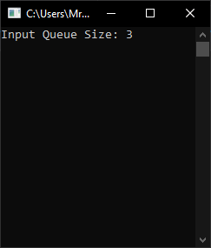

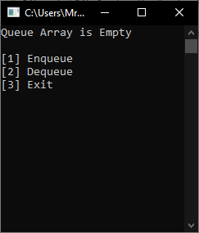

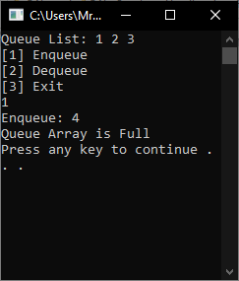

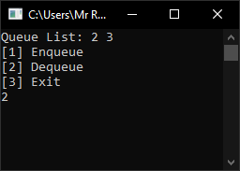

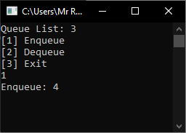

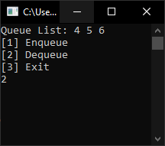

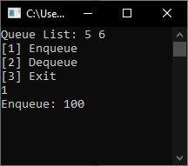

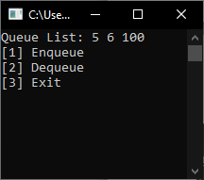

**Source code:**

#include<iostream>

#include<String>

using namespace std;

string input;

int size = 0, Queue[5], front = -1, rear = -1;

bool isEmpty(){

return front == -1 && rear == -1;

}

bool isFull(){

return rear == front;

}

int EnQueue(int x){

if ((rear + 1)% size == front)

{

cout << "Queue Array is Full\n";

system("Pause");

return 0;

}

else{

if (isEmpty()){

front = rear = 0;

}

else{

rear += 1 % size;

}

Queue[rear] = x;

}

}

int DeQueue(){

if (isEmpty()){

cout << "Queue Array is Empty\n";

system("Pause");

return 0;

}

else

{

if (isFull())

{

front = rear = -1;

}

else{

cout << "Element Deque is : " << Queue[front];

front = (front + 1) % size;

}

}

return 0;

}

void display(){

if (isEmpty()){

cout << "Queue Array is Empty\n";

}

else

{

cout << "Queue List: ";

for (int i = front; i <= rear; i++){

cout << Queue[i] << " ";

}

}

cout << endl;

}

void array(){

int ints;

system("cls");

display();

cout << "[1] Enqueue \n";

cout << "[2] Dequeue \n";

cout << "[3] Exit \n";

cin >>input;

if (input == "1"){

cout << "Enqueue: ";

cin >> ints;

EnQueue(ints);

return array();

}

else if (input == "2"){

DeQueue();

return array();

}

else if (input == "3"){

system("exit");

}

else{

return array();

}

}

int main(){

try{

system("cls");

cout << "Input Queue Size: ";

cin >> input;

size = stoi(input);

Queue[size];

array();

}

catch (exception e){

cout << "Invalid Input\n";

system("Pause\n");

return main();

}

system("Pause");

return 0;

}